The Material Journey
The material handled by the inspected system is combined product comprising lump/coarse ore together with fines. Fines are already present in the product stream and additional fines are generated through crushing and subsequent handling. Their presence is therefore not itself a defect; the audit concern begins when product or process water leaves its intended material-handling or process path before reaching the stage designed to receive or control it.
From the underground crusher onward, the conveyor system is intended to transport combined product through successive transfer and processing stages while retaining it within the designed material path. A portion of the finer material can remain adhered to the belt after discharge and travel back with the return side of the belt; this residual material is referred to as carryback. If it is not removed and retained at an appropriate discharge or cleaning point, it can progressively fall from the return belt and become distributed spillage along the conveyor route. Because fines form part of the saleable/product stream, the objective is not simply to clean them from the belt, but to remove them in a controlled manner and keep them within the intended process path wherever practicable. Residual carryback should therefore be removed at appropriate discharge locations and kept inside the process; process water should remain within the screening/washing route; and material deliberately removed during unavoidable operating interventions should remain under controlled temporary handling and be recovered through an approved process route..
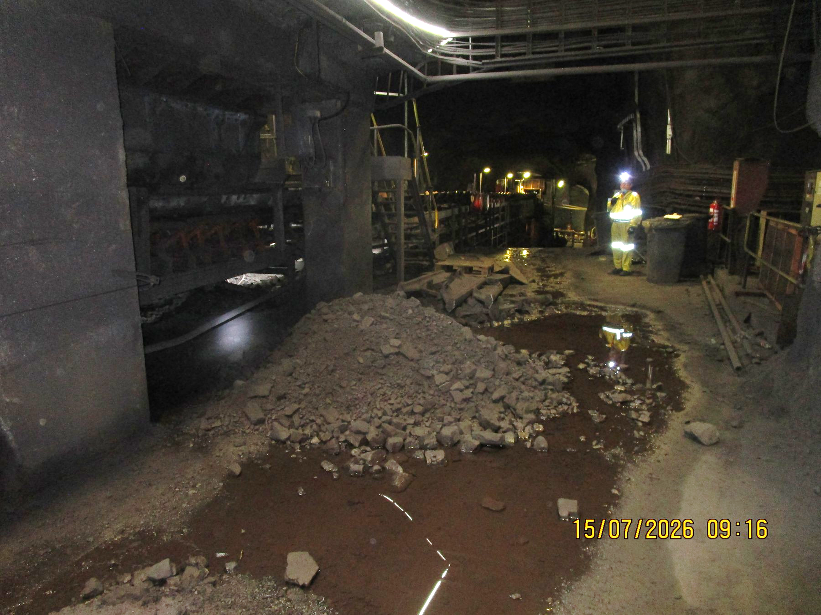  UGCrusher-REF-001 — mixed lump/fines accumulation at the underground start of the inspected conveyor ecosystem. | 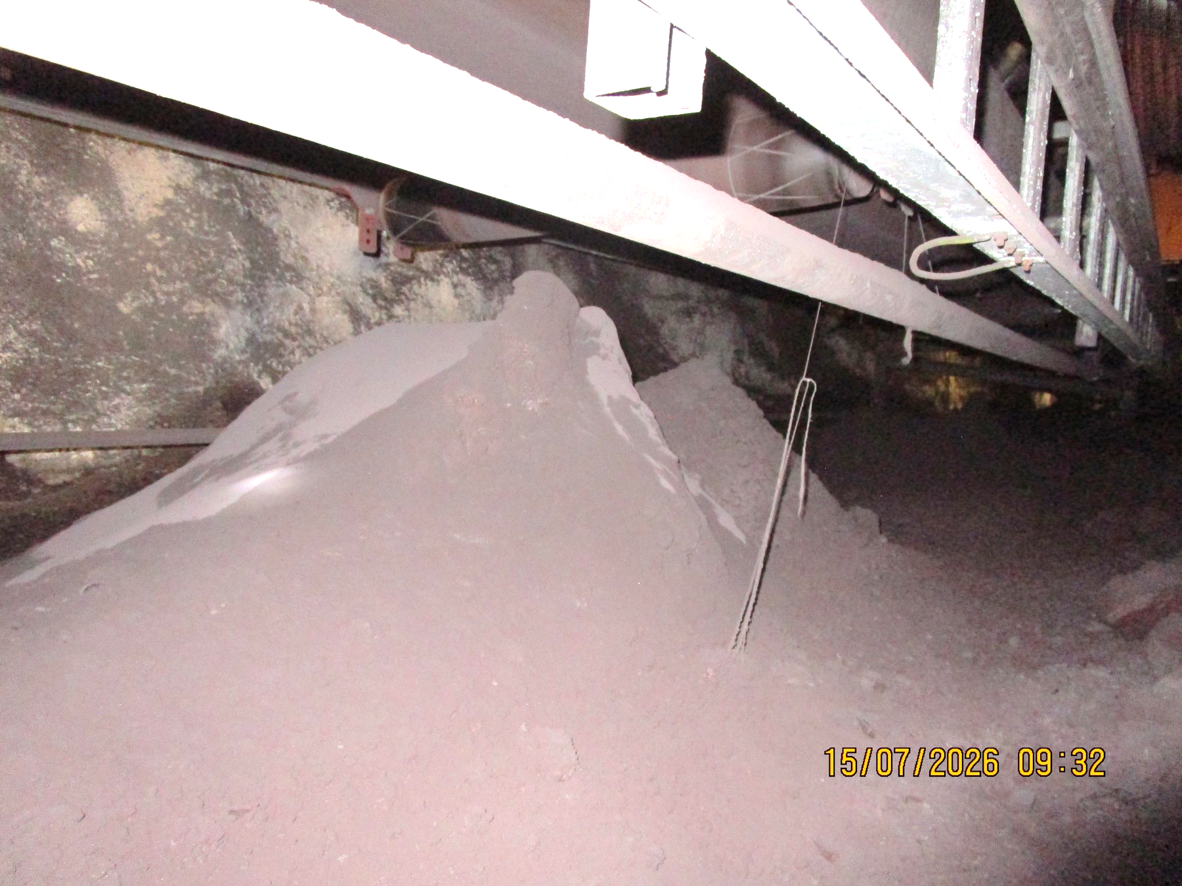  UGUC05_04_03_02_01-REF-006 — severe local accumulation along the continuous underground conveyor route.
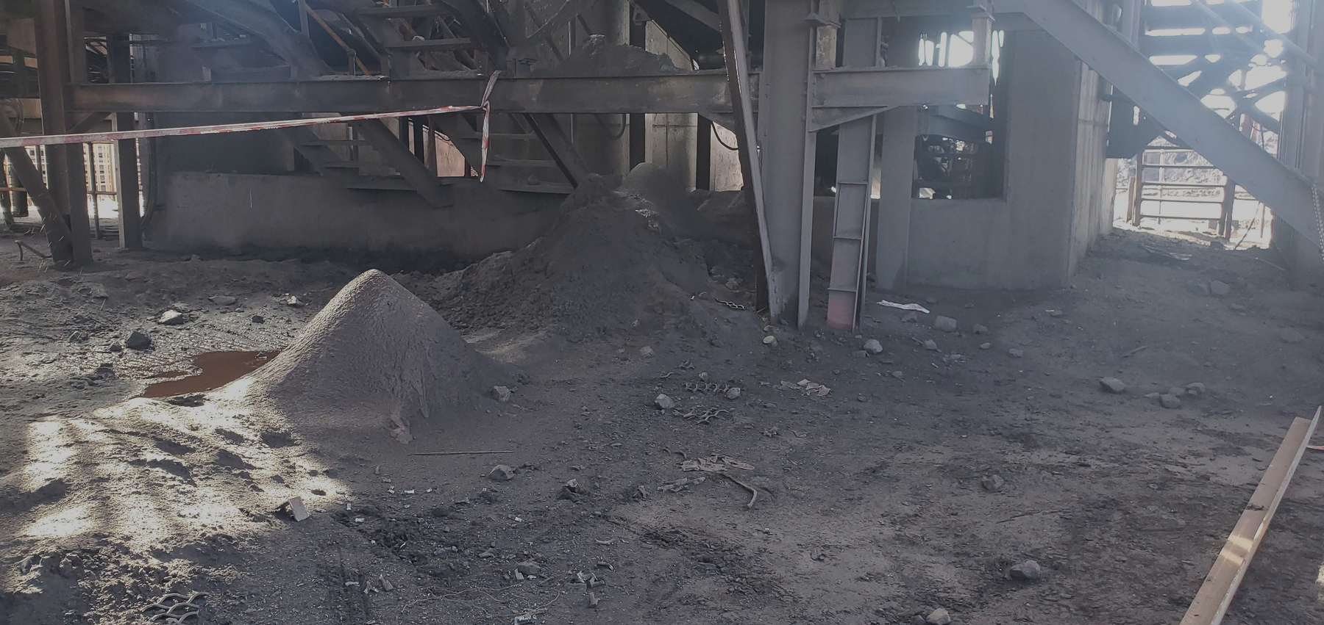  CV04-REF-005 — wider surface-plant view showing multiple accumulated fines piles beneath and around the conveyor structure. | 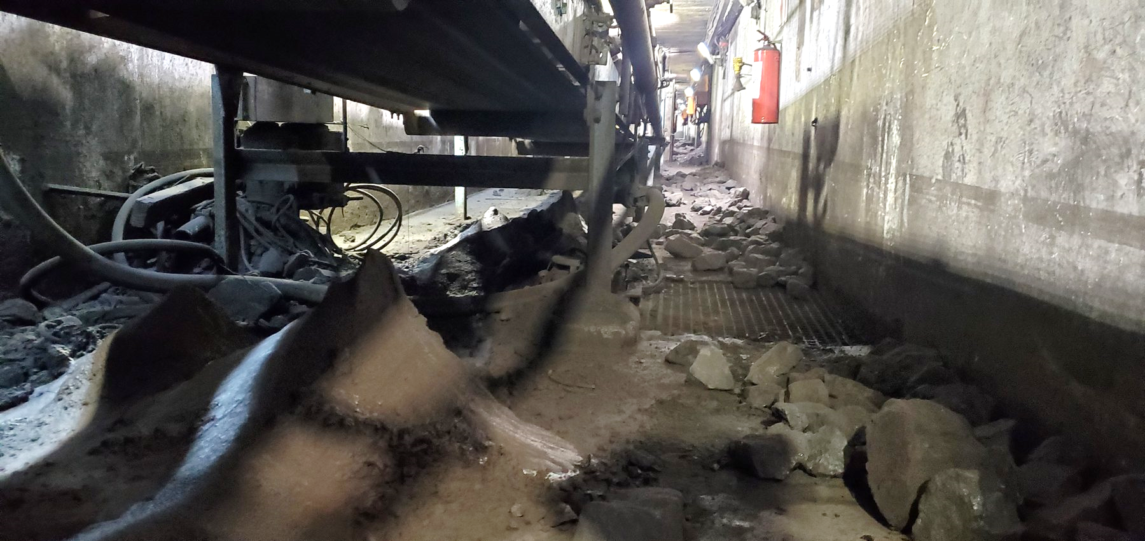  W10-REF-006 — mixed coarse product and fines distributed below the conveyor around components within the restricted tunnel area.
READER TAKEAWAY | The report concerns loss of process containment during transport — not the mere presence of fines, lump ore or process water within the material-handling system.

